City of Bastrop Inspection Requirements

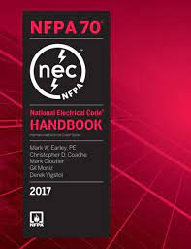

National Electric Code (NEC)

NOTE: The commercial energy code inspections as required by the International Energy Conservation Code (IECC) are incorporated in the inspections listed and are preceded by the letters IECC.

Annex H, 80.19 (F) inspection and approvals
Upon completion of any installation of electrical equipment that has been made under a permit other than an annual permit, an inspection shall be requested and completed.
Any portion of the electrical installation that is to be hidden from view by the permanent placement of parts of the building, including electrical equipment, shall not be concealed until it has been approved by the inspector. Where the concealment of equipment proceeds continuously, the inspector shall be given due notice in advance and inspections shall be made periodically during the progress of the work.
IECC C105.2.5 Verify lighting system controls, components, and meters as required.
IECC C105.2.6 Verification of the installation and proper operations of all required building controls, and documentation verifying activities associated with required building commissioning have been conducted.
Annex H, 80.25 Connection to electrical supply
It shall be unlawful for any connection to a supply of electricity or to supply electricity to any electrical equipment installation for which a permit is required or that has been disconnected or ordered to be disconnected.
Temporary power shall be permitted to be supplied to the premises for specific needs of the construction project, as determined by the building official.

City of Bastrop Inspections
  - Electric Pre-pour/Grounding
  - Electric Trench
  - Electric Temporary Pole
  - Electrical Above Ceiling
  - Electric Rough
  - Electric Meter Release
  - Electric Final

